NAME: Caroline Nyambura

Email: [caroline.nyambura@womentechsters.org](mailto:caroline.nyambura@womentechsters.org)

Date Of Submission: 18th July 2021

Task: Assignment Practical 5

**QUESTION 1**

With the help of an active directory add the Headquarters and the two sales locations.

**ANSWER**

1.I will start by outlining the organization in my notepad as screen shorted here below.

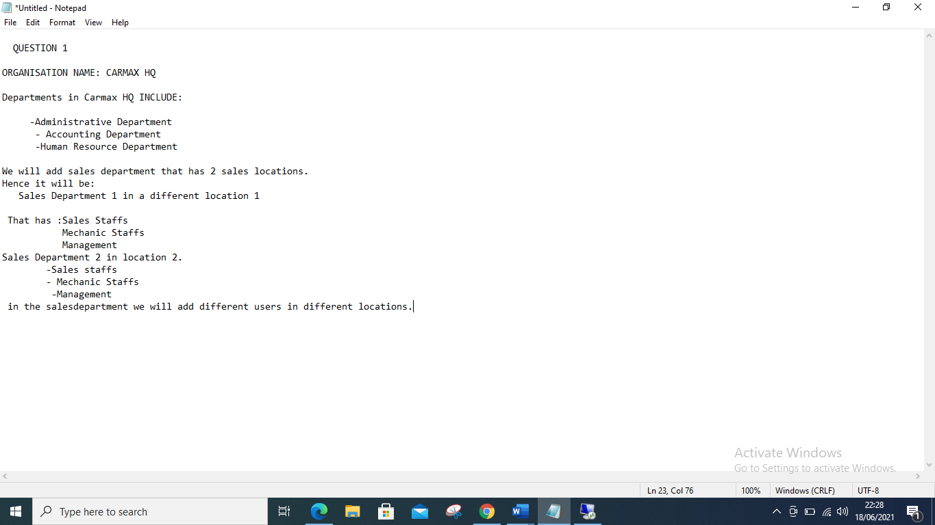

2.I will now create the Headquarter and the different departments including the sales department as indicated below. My domain server is known as Biro server. Local

A,) Start by clicking the tools on the server manager, choose and click active directory users and computers.

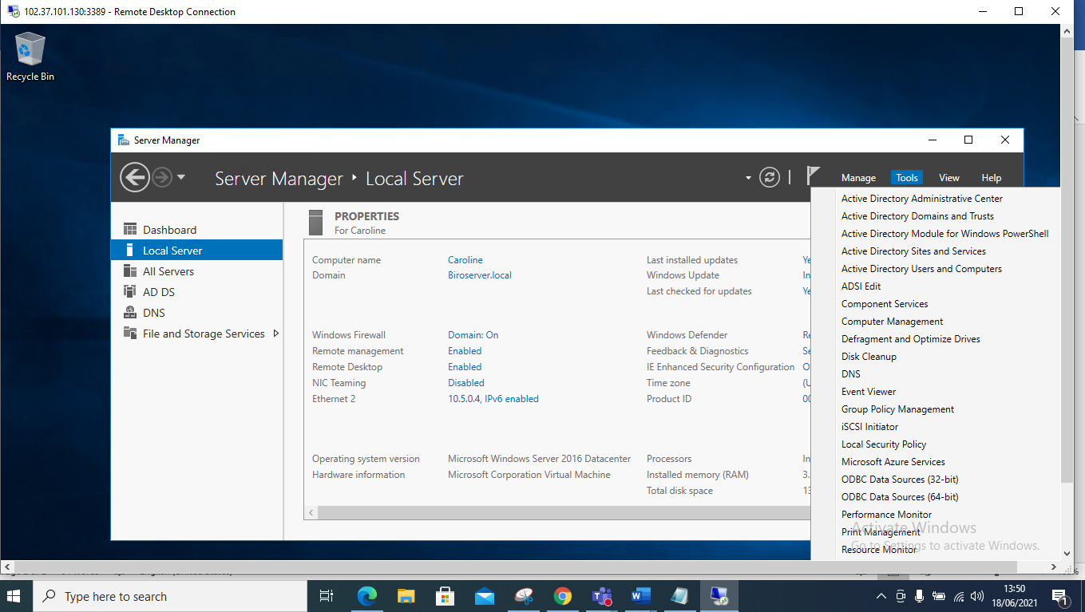

3.I will then click on the drop-down menu of my active domain server which is Biro server, afterwards I will right click on an empty space and a pop up appears, I will click on New and select the option of Organizational unit

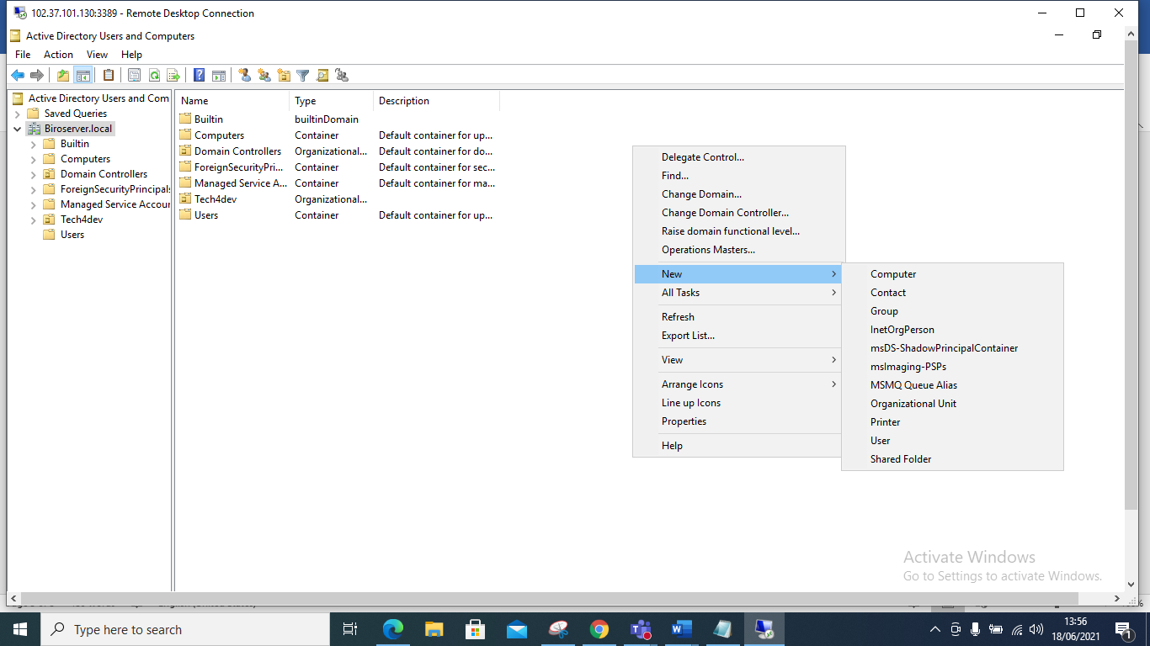

4. Once you Click on the organizational unit a pop-up box appears and that’s where I type in my organization name CarMax and I finally click Okay.

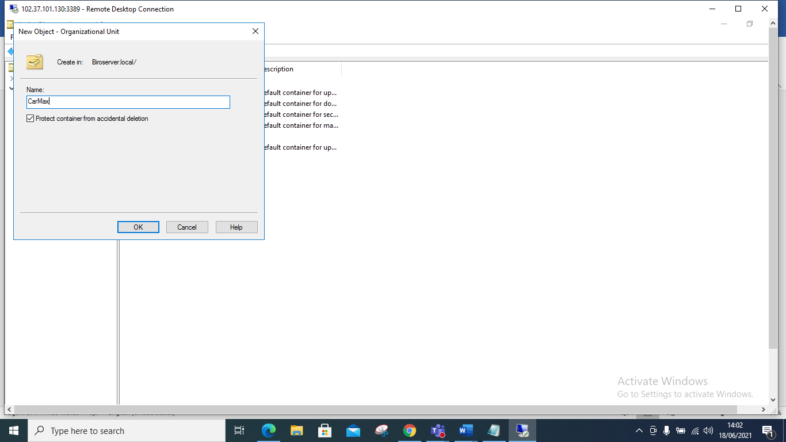

5. One can see it in the active directory though it has nothing

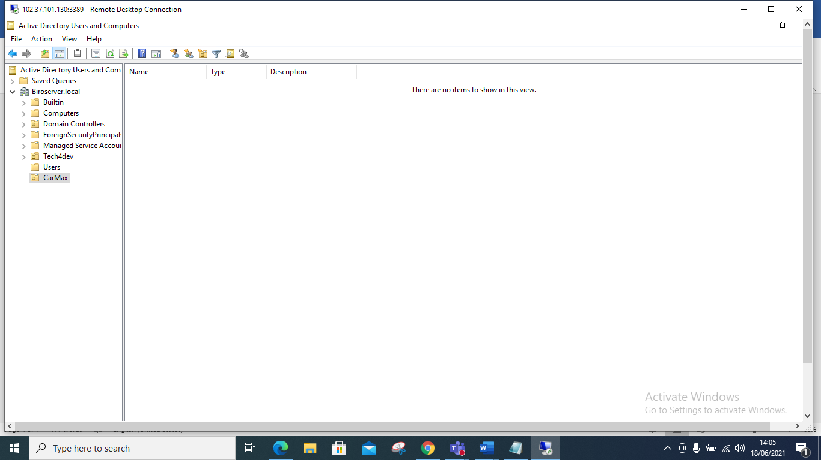

6.We will now click on the CarMax Organization and add the different departments, this is done by clicking on CarMax, a pop up appears, click on new, and click on Organizational Unit, and I will create my departments such as: Administrative Department.

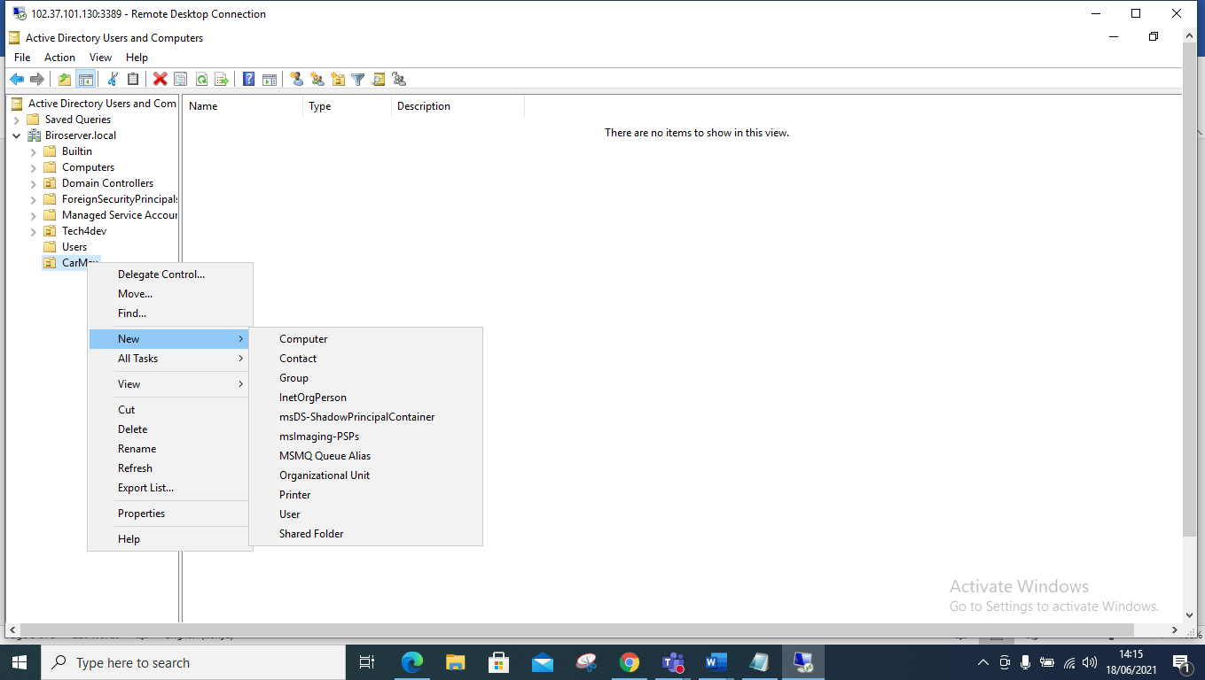

**ADMINISTRATIVE DEPARTMENT** then click Okay to create the department.

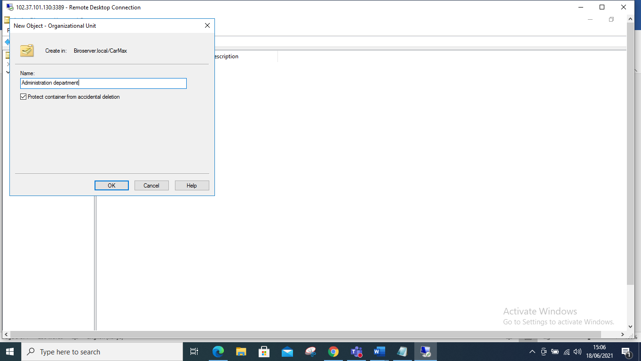

**ACCOUNTING DEPARTMENT,** CLICK OKAY to create the department.

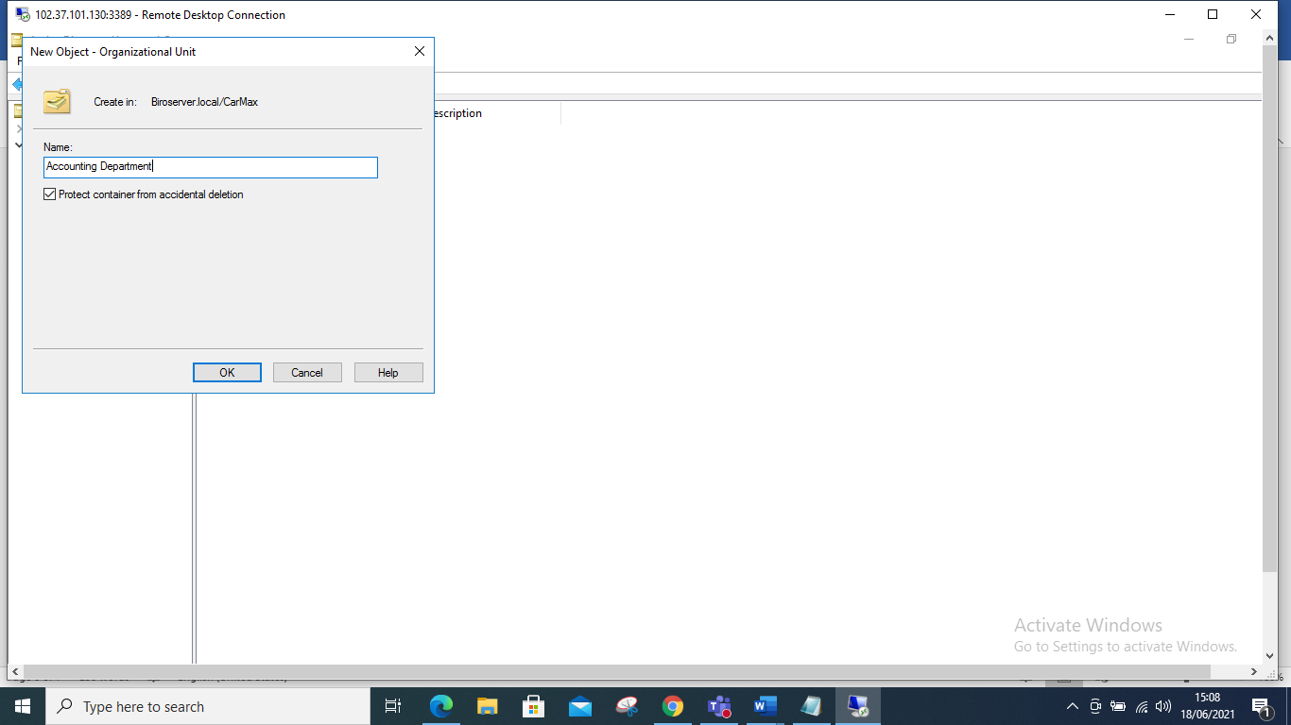

**HUMAN RESOURCE DEPARTMENT,** click okay to create the department.

Let’s now create and add the **Sales Department** as illustrated below and click okay . Hence this will be Sales Department1

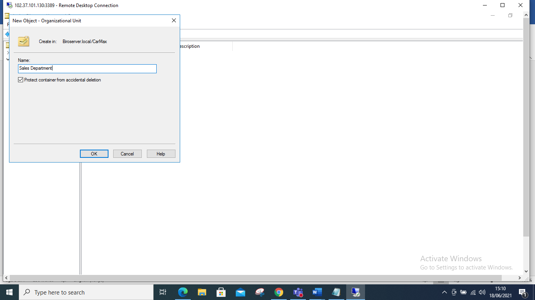

Sales Department 2

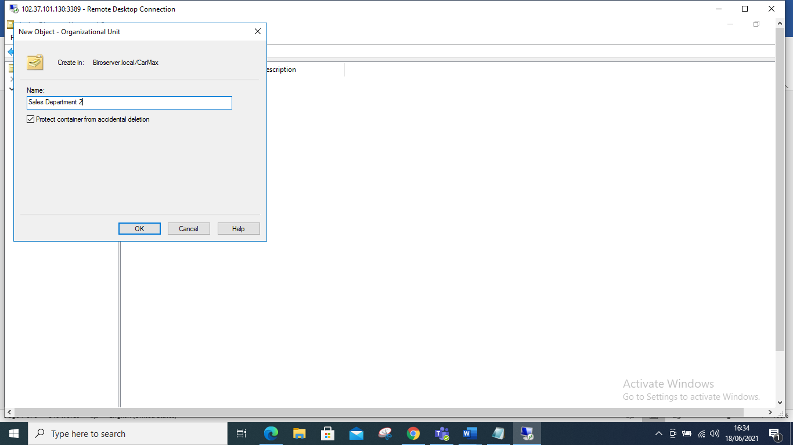

**QUESTION 2**

**Under each unit add dummy users**

**ANSWER**

I will start by adding a user in the administrative department this is done by right clicking in the administrative department a pop up appears, select new then click on user and a pop-up box appears, hence input your user’s name.

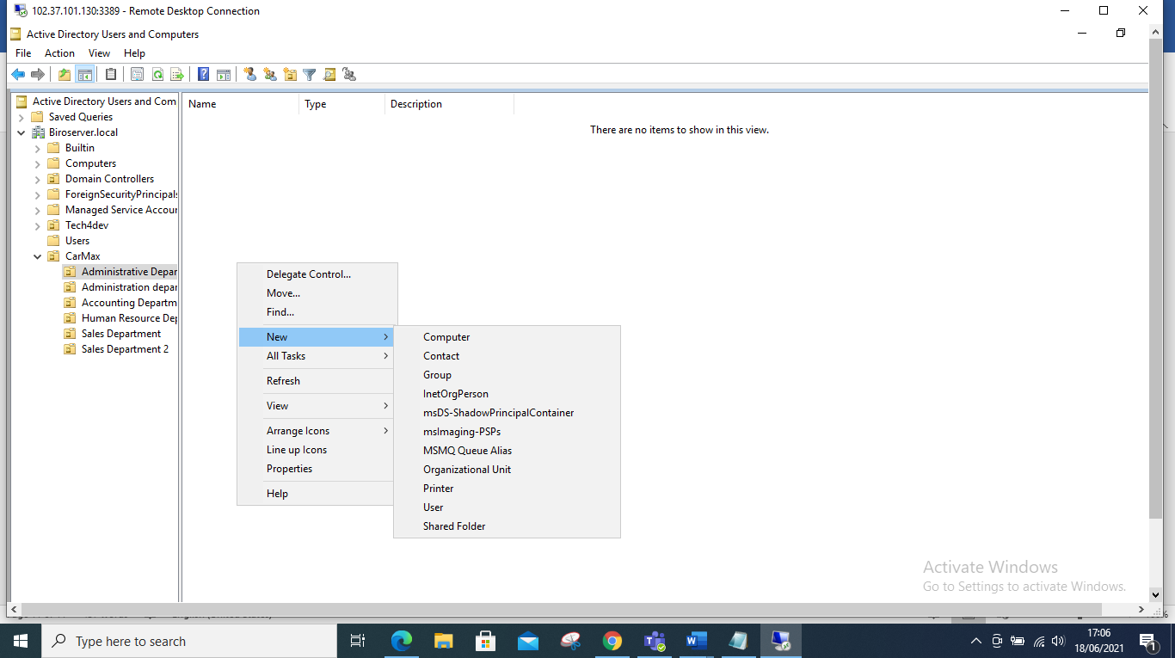

My administrative user’s name will be Carol Agnes as illustrated once I fil I will click on next so that I input my password.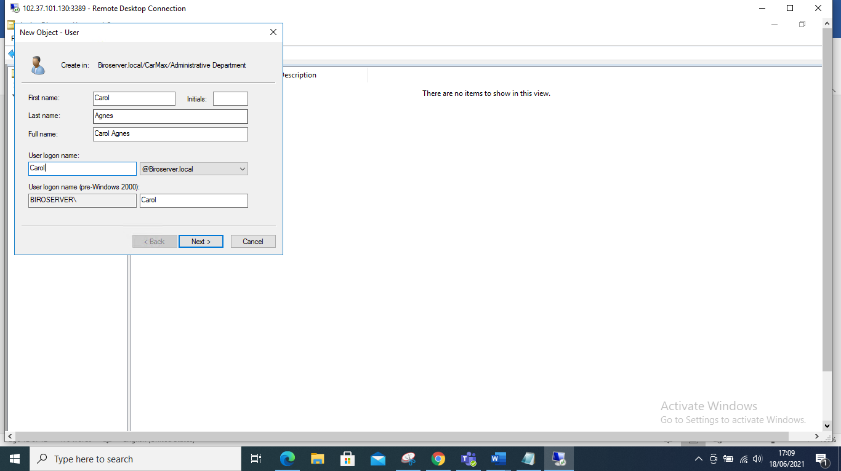

Hence, I input my password and I would like the user to change password once they login, hence I tick on the box as shown below click on next:

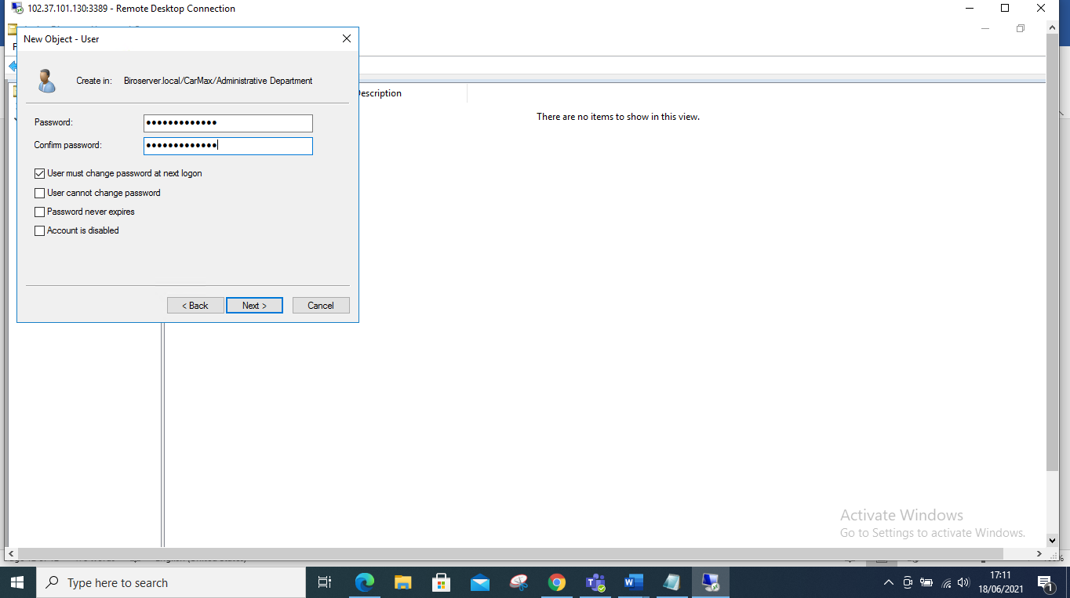

**Another pop up box appears and I click finish**

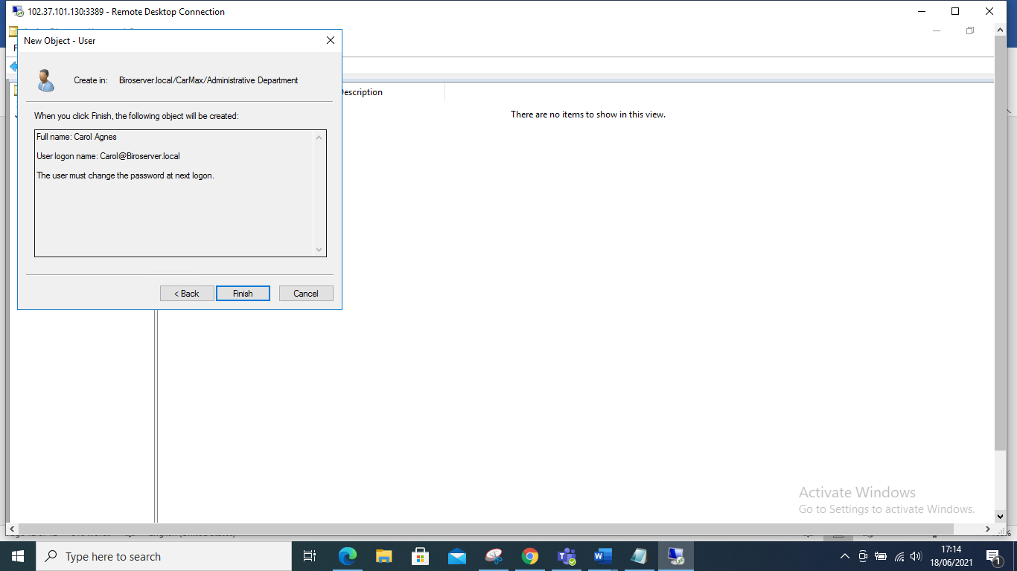

**ACCOUNTING Department adding users**

**I input the users name is known as Christine Maina.**

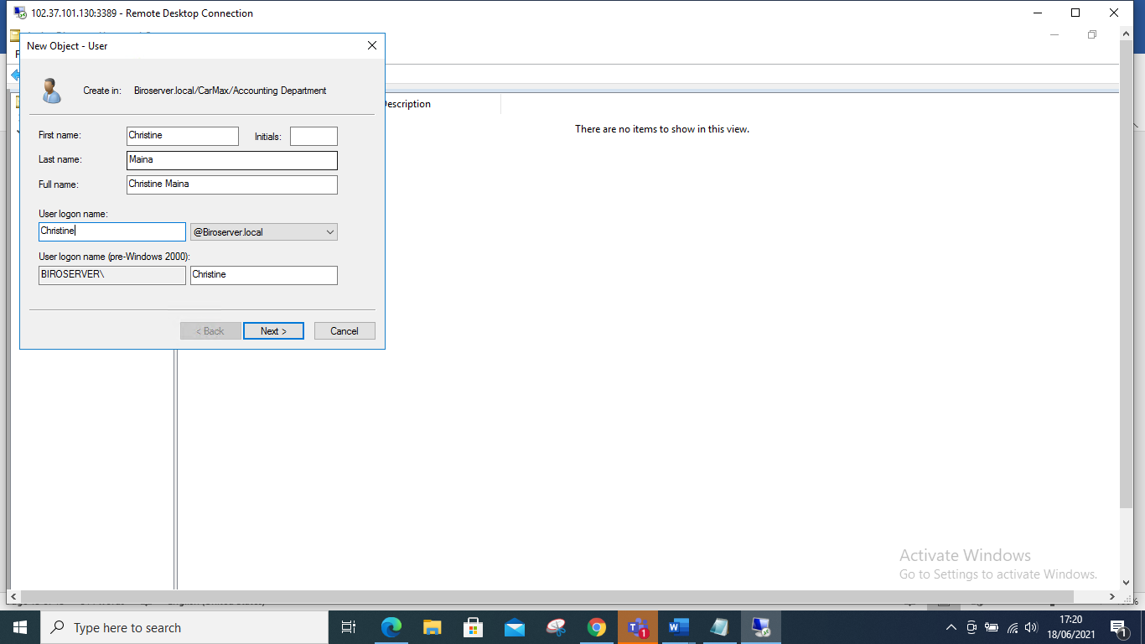

**I input the user’s password and tick on the first box since I want them to change their password once they login in and i proceed to click next**

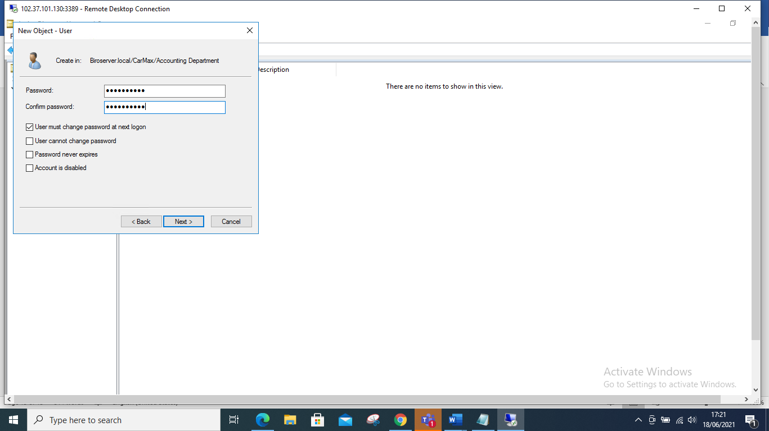

And finally click finish

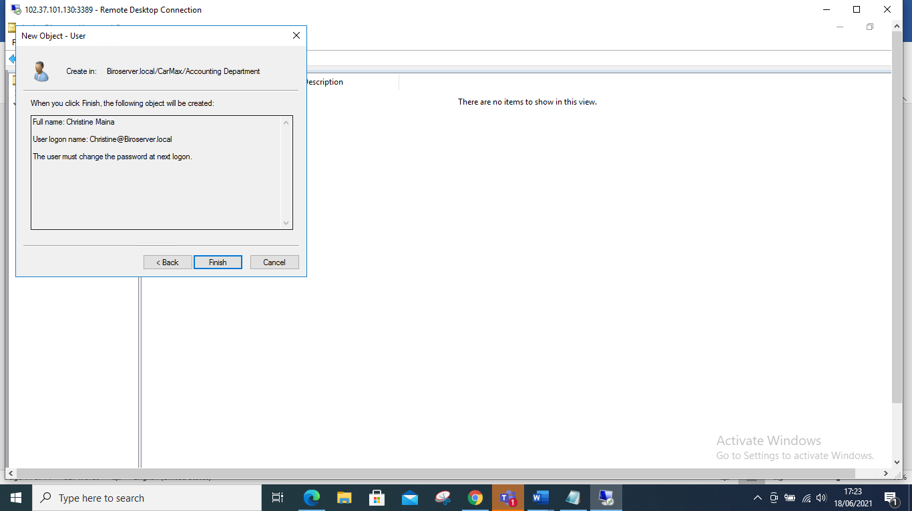

**Creating Users in Human Resource Department**

Right click on the Human resource Department, click new and click on Users, hence input the name of the users in that department and then click on nex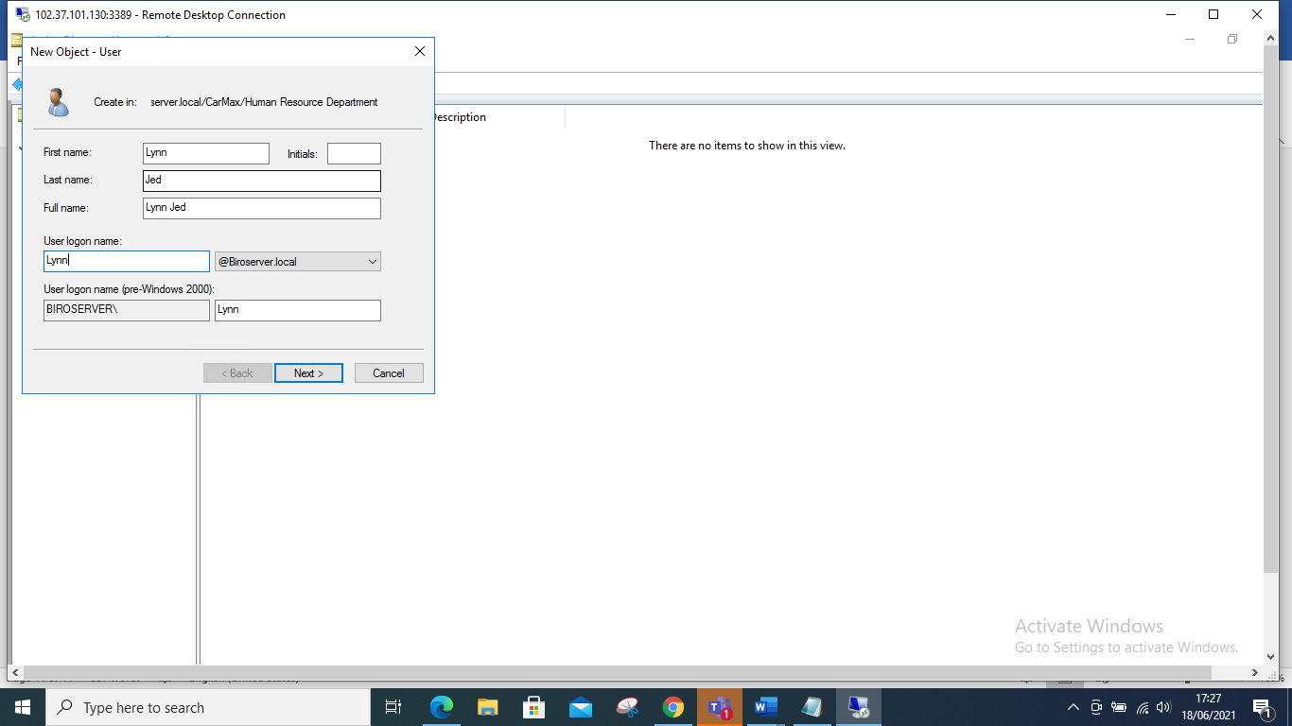

**Input Password and click on next**

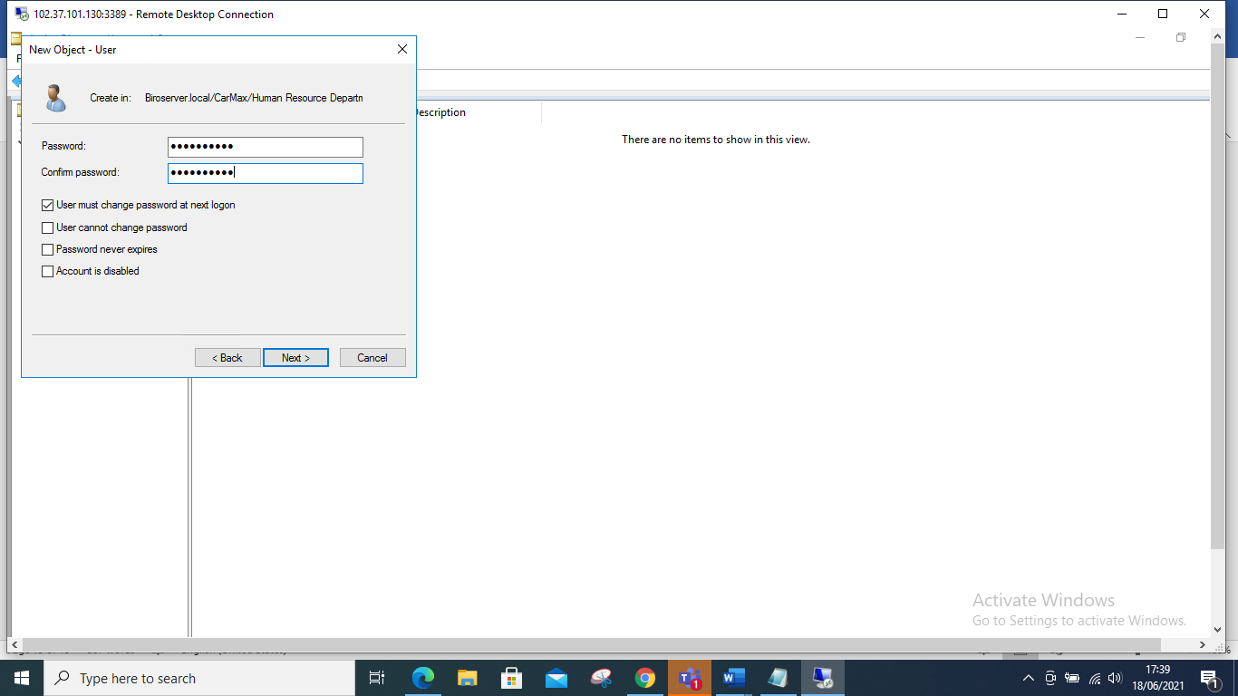

**Finally click on Finish**

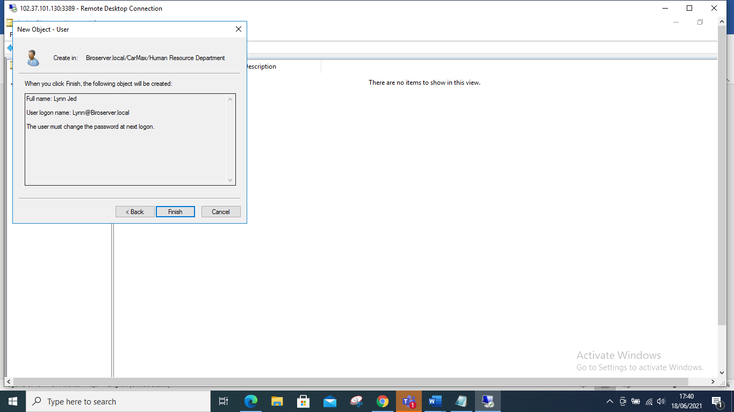

**ADDING USERS ON THE SALES DEPARTMENT 1**

1. I will click on sales department 1
2. Then click on new, then user and input the names of the user and click next

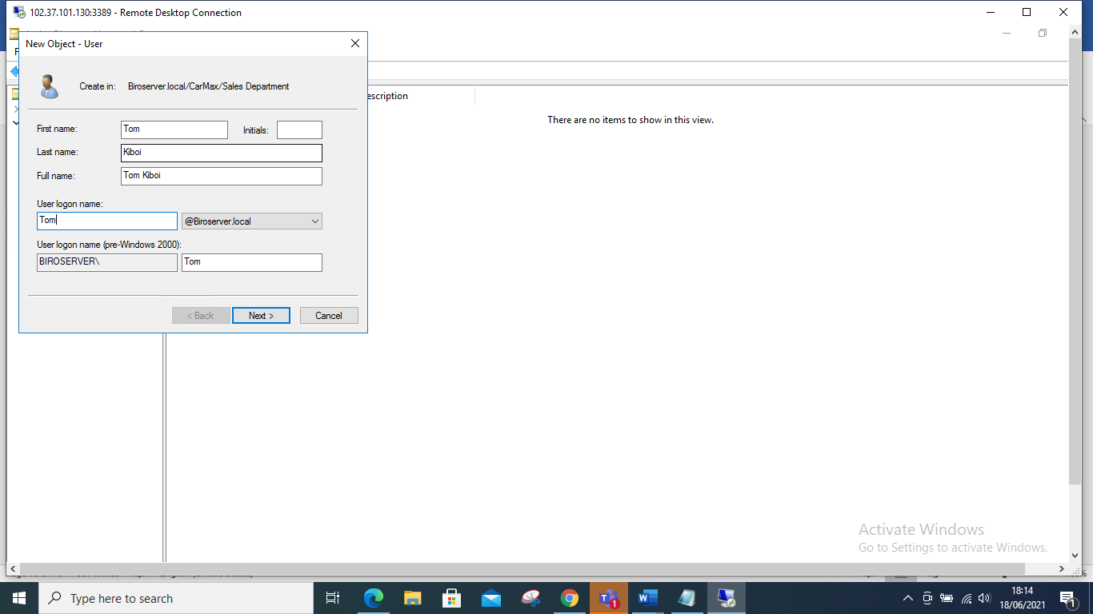

Input the password and tick the box that you would want the user to adhere to once they login and click next.

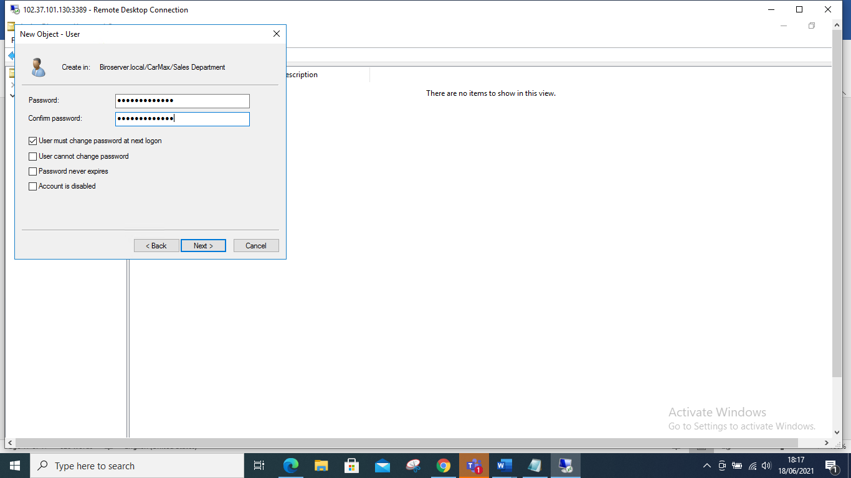

Finally click finish to input the user in the sales depart1

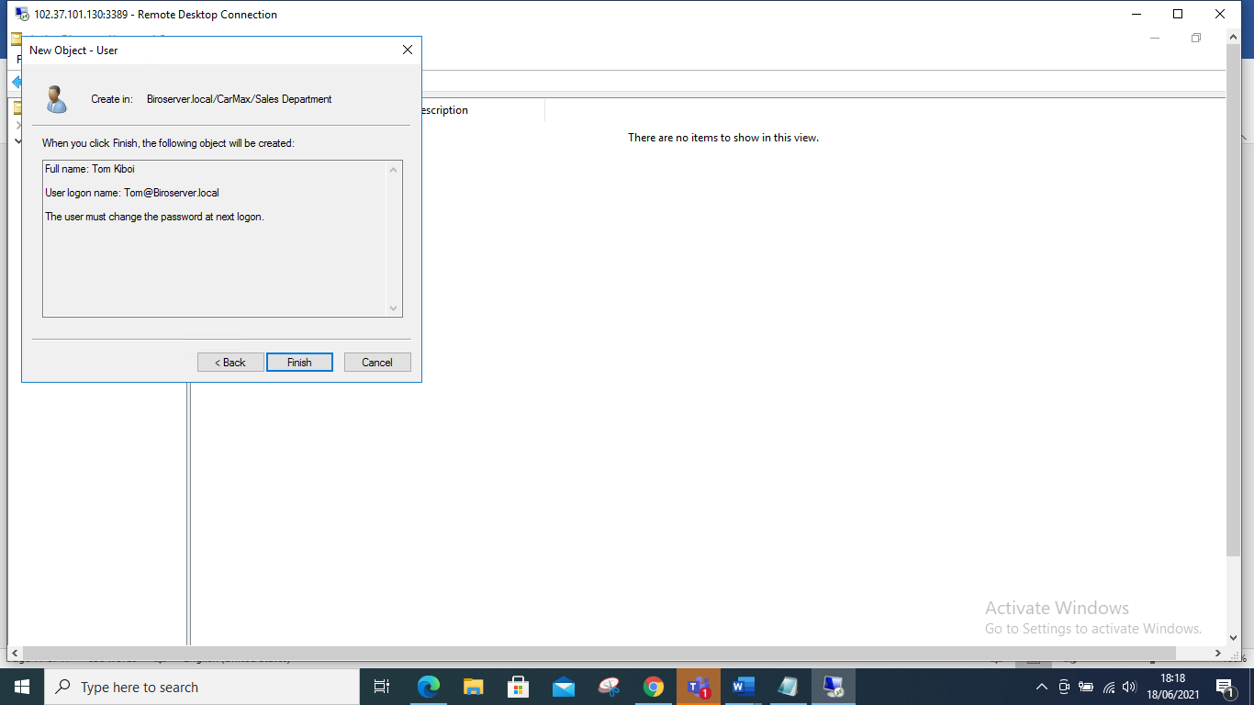

Adding user in Sales Department 2, input the details of the user Aclick next to input the password

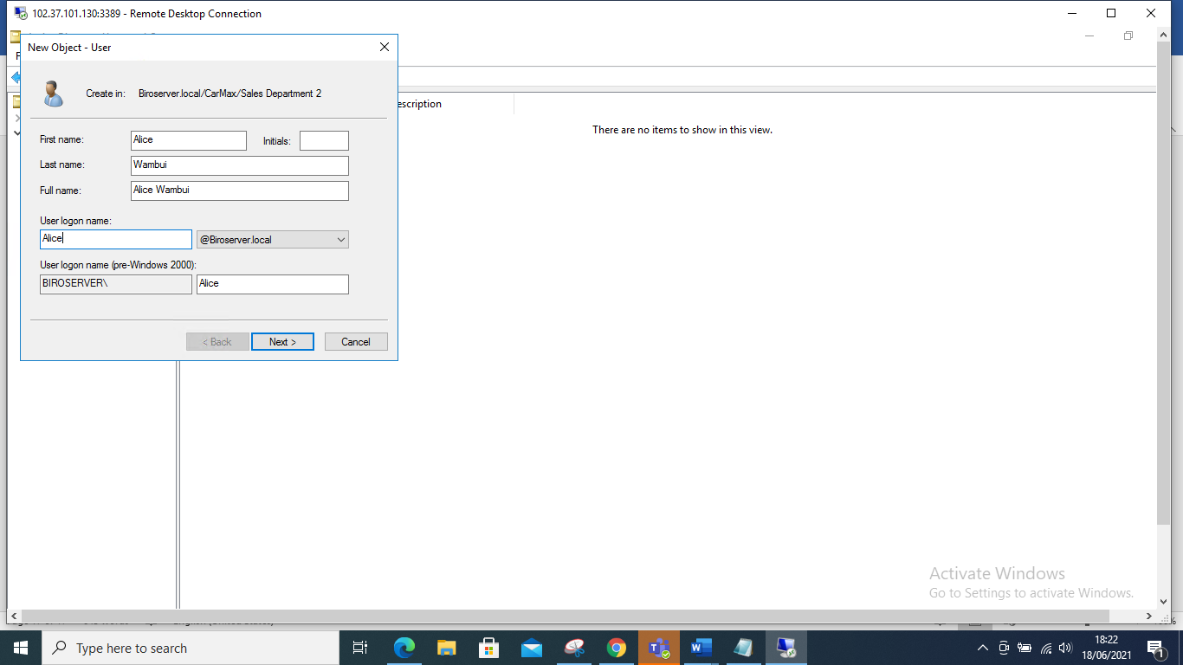

Let’s input the Password and click okay.

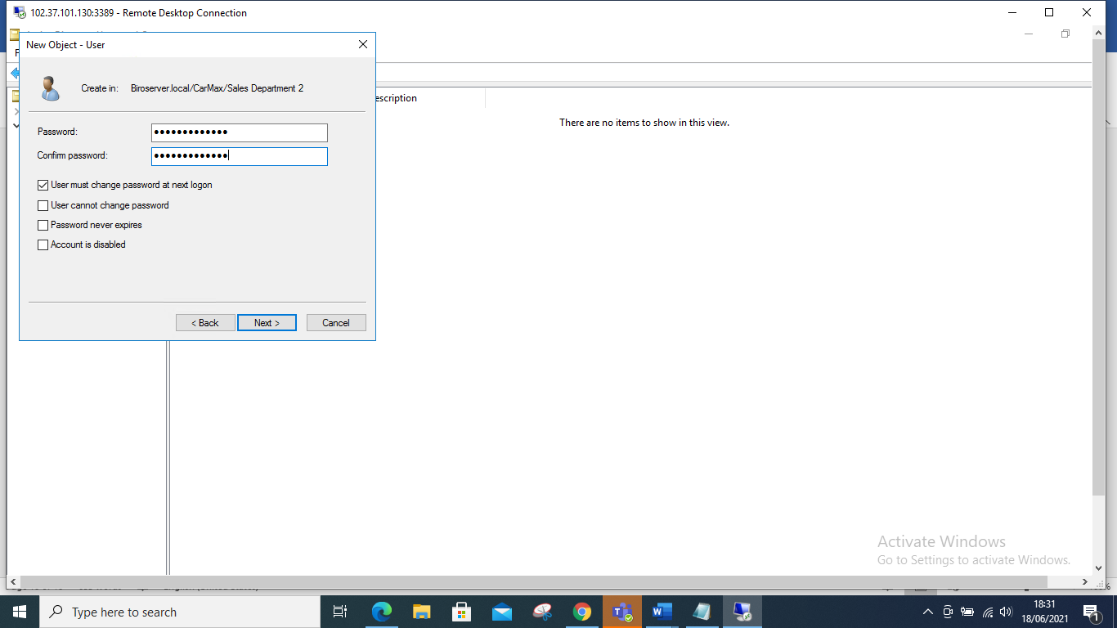

And finally click on Finish to create the user.

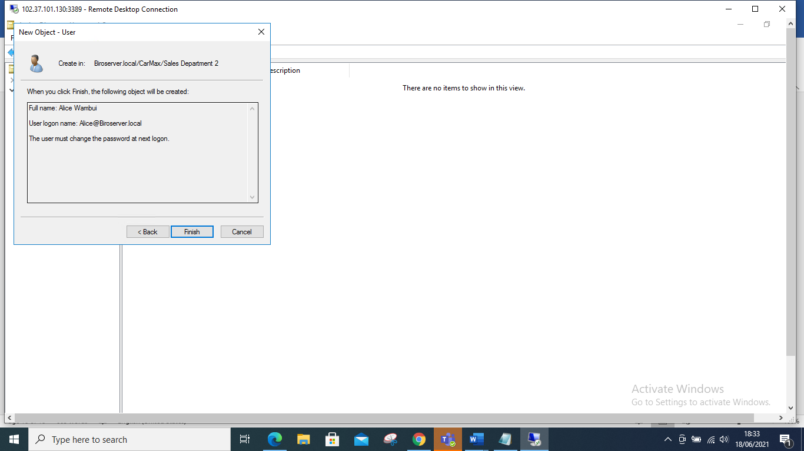

**Question 3**

**Assume a user in sales staff is promoted to administrative department, describe how you will handle this and effectively transitioned to administrative unit.**

**ANSWER**

1.I will use sales department 1 where I assume Tom Kiboi has been promoted to administrative department

**Step 1**

Right click on administrative group and click on new, select group.

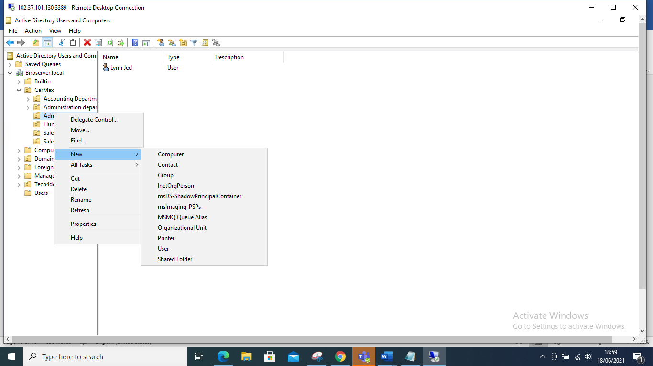

A Pop-up box appears, input his name and check on administrative group whether his name has been added.

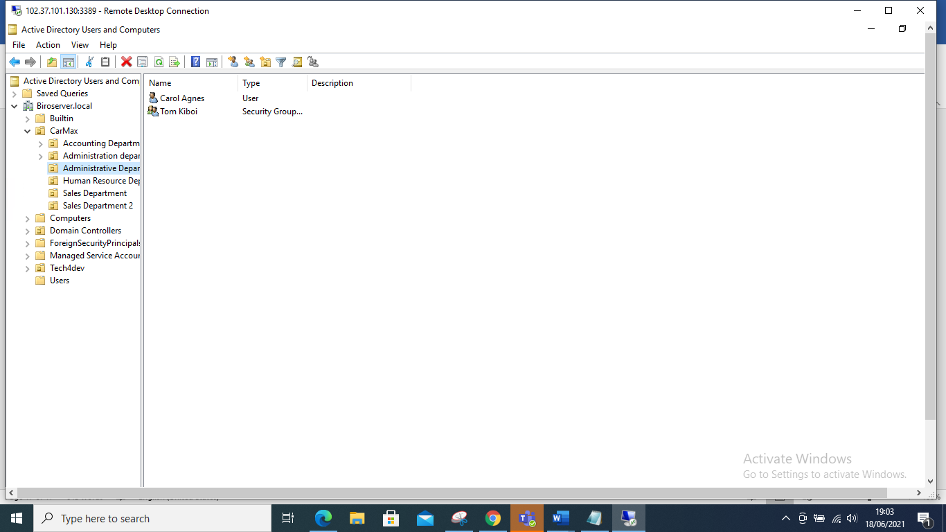

To ensure he is no longer in the sales department 1 you have to check back and ensure the user is no longer there after moving him to the admin department

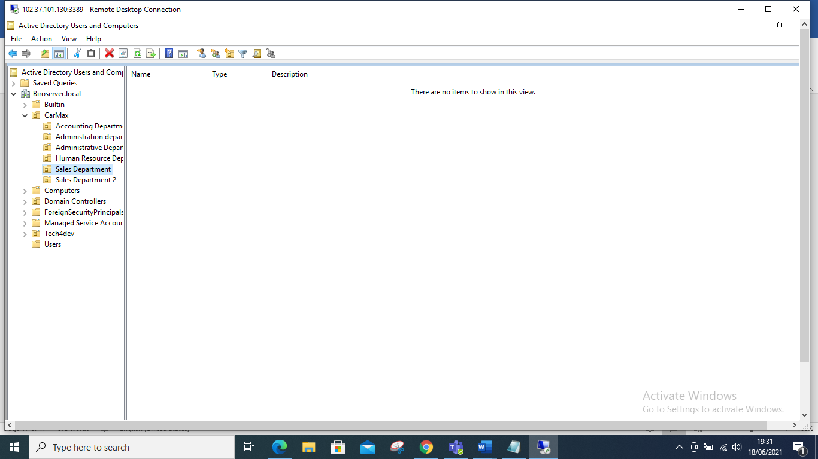

**Question 4**

Assuming one dummy user in mechanic staff has gone for leave for one month, give a detailed description of how you will ensure their user account is in active and cannot be accessed by any other person during the one-month leave.

**Answer**

1. There are two methods, one can click on the name of the user, then click on account, scroll down and tick disable and click apply then okay screen short shown down below.

I will use Alice Wambui from Sales department 2, who in my view she is a mechanic staff and disable her account.

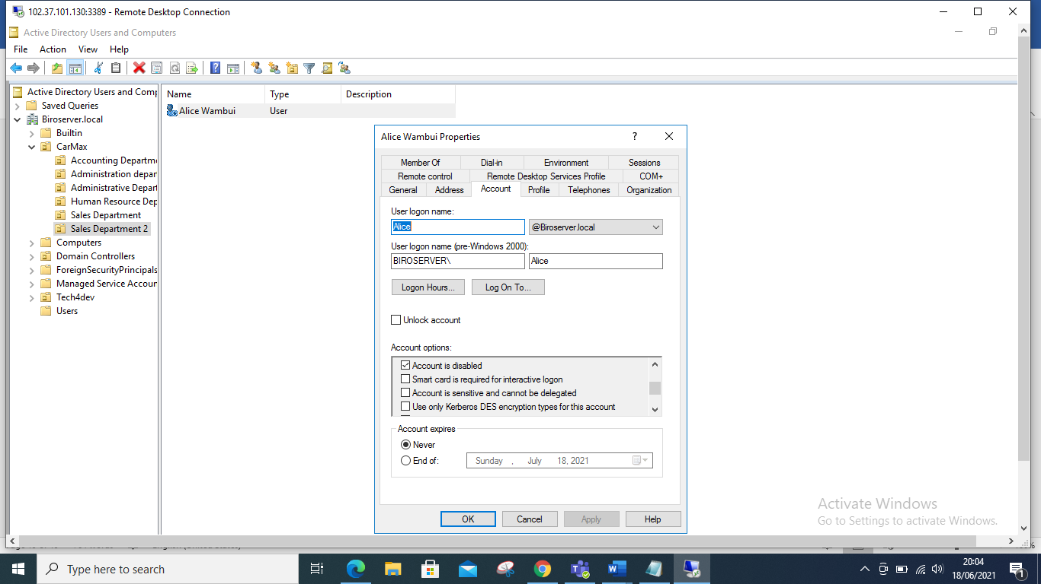

**Method 2**

You can right click on the name of the user that is Alice Wambui and disable her account directly.

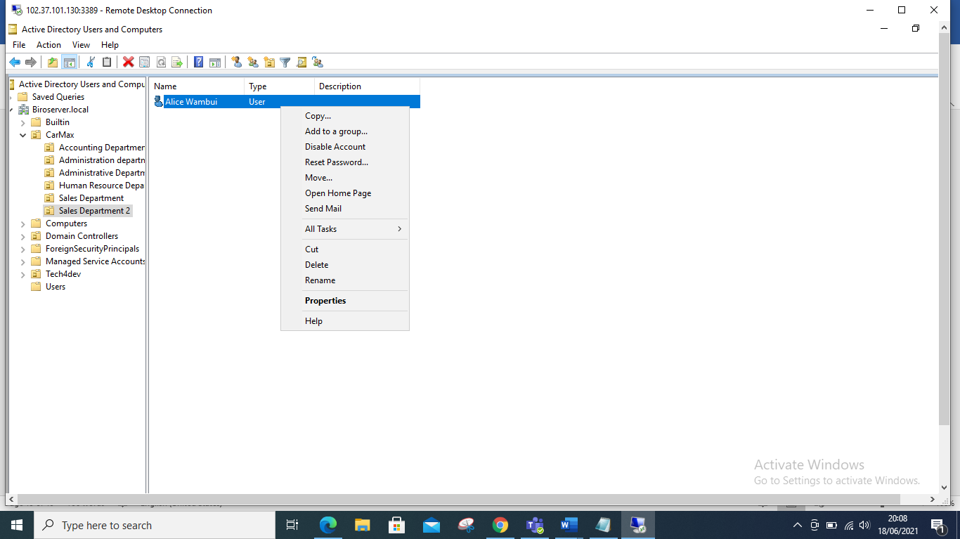

**Question 5**

In accounting department, we want to maintain high notes of security especially to the computers. Add a computer policy under accounting dept to ensure all computers are locked or disabled after 3 minutes of inactivity.

**ANSWER**

**STEP 1**

1 Click on tools, and select group policy management

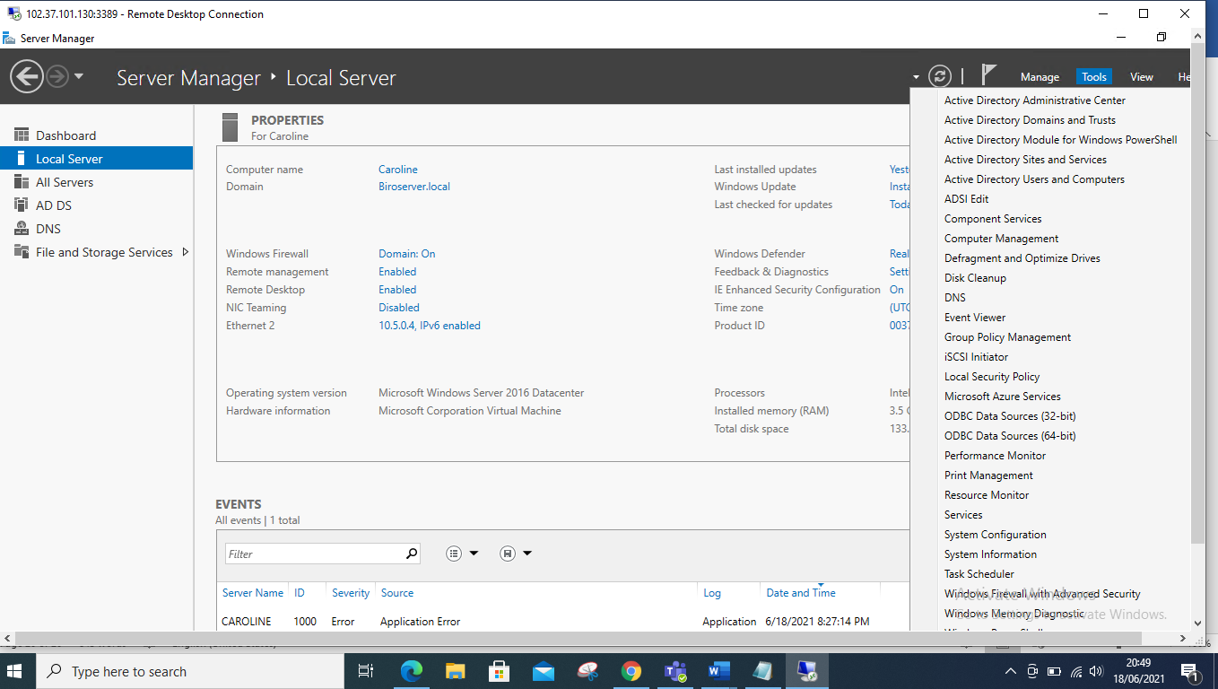

1. Click on your server, mine is Biro server, and choose and click on your Organization, Mine is known as CarMax. Then I click on the accounting department, screen short illustrates below.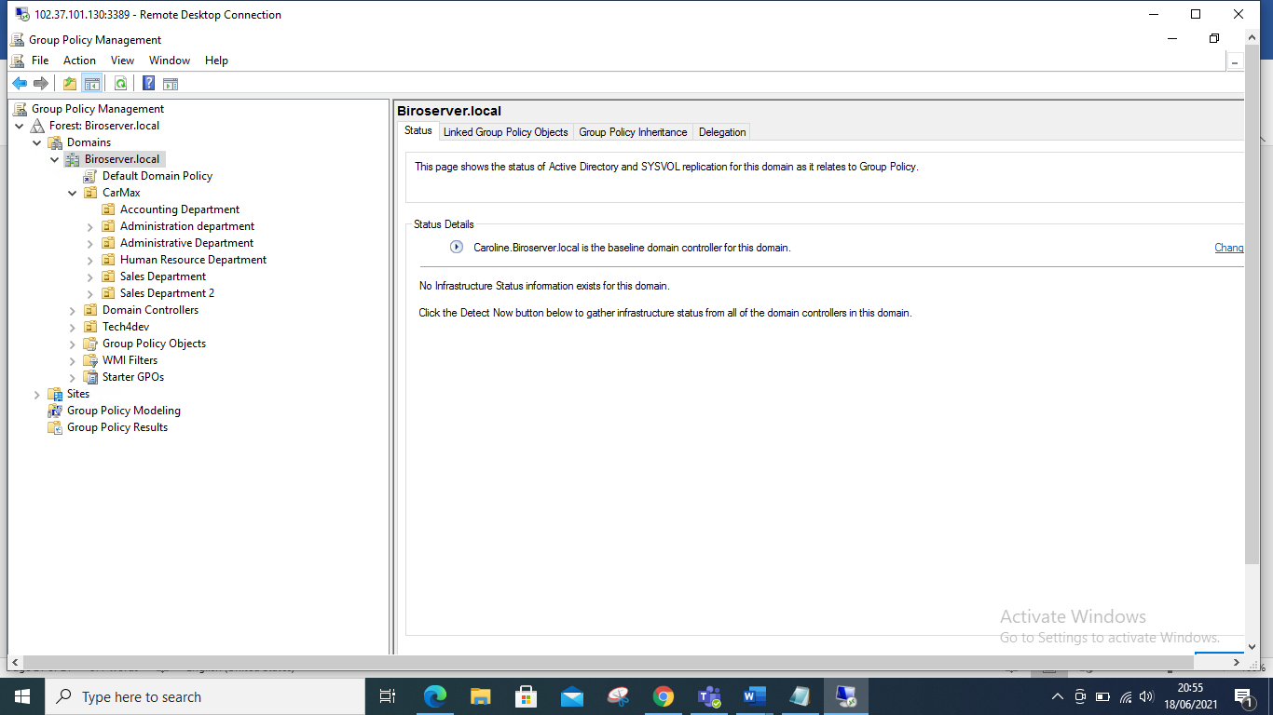
2. Right Click on the Accounting Department, and click on, create a Gpo on this domain and link it here.

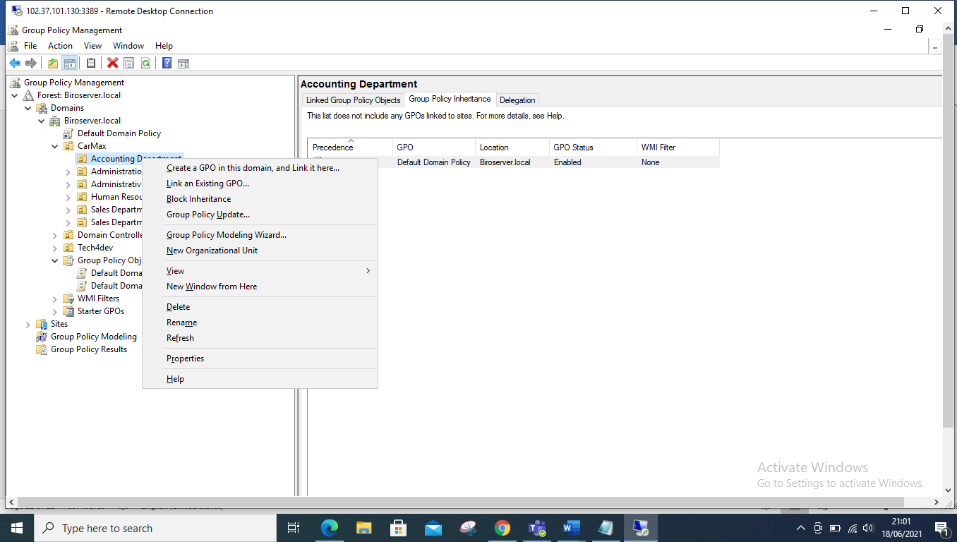

4.A pop up box appears input a name, example, mine I name it Timed out 1, and hence click okay.

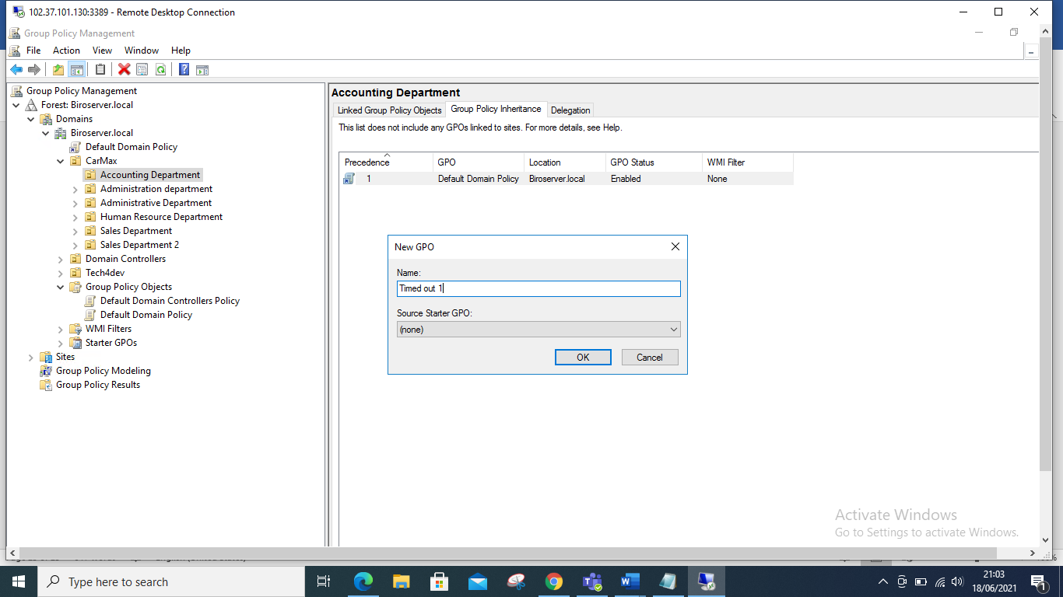

5.Hence after clicking Okay, click on the timed out that will show a pop up appears click okay.

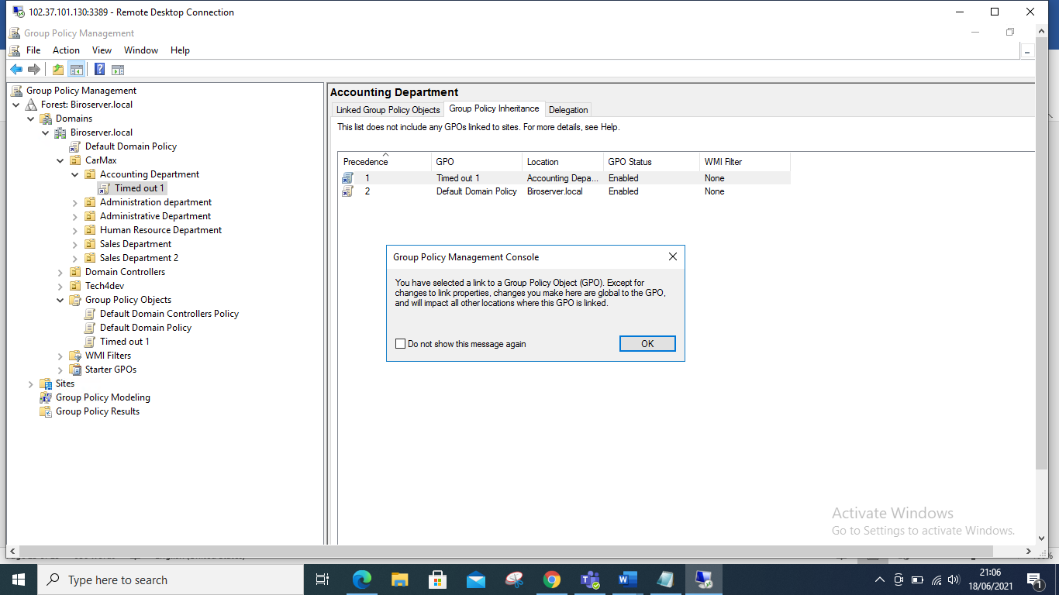

6.Once you Press okay, click on settings and a pop-up box appears, hence close it, then right click on the details and select edit from the pop-up box.

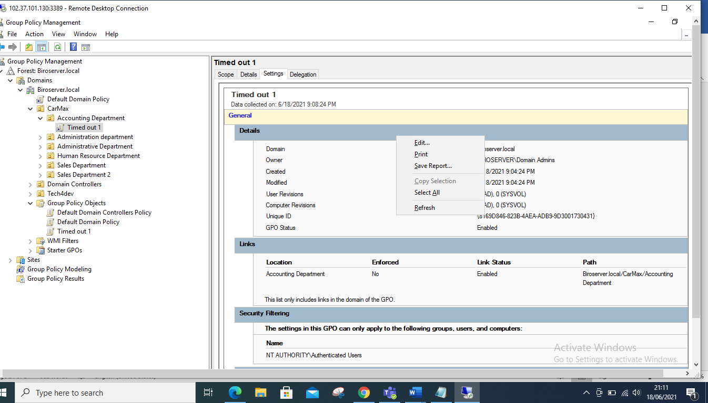

7.A pop up box appears, click on the drop down on policies and click on the drop down on Windows Settings, then click on the drop down on security settings and select Local policies. Under Local Policies click on the drop down and select Security Options. The screen short explains this whole process below.

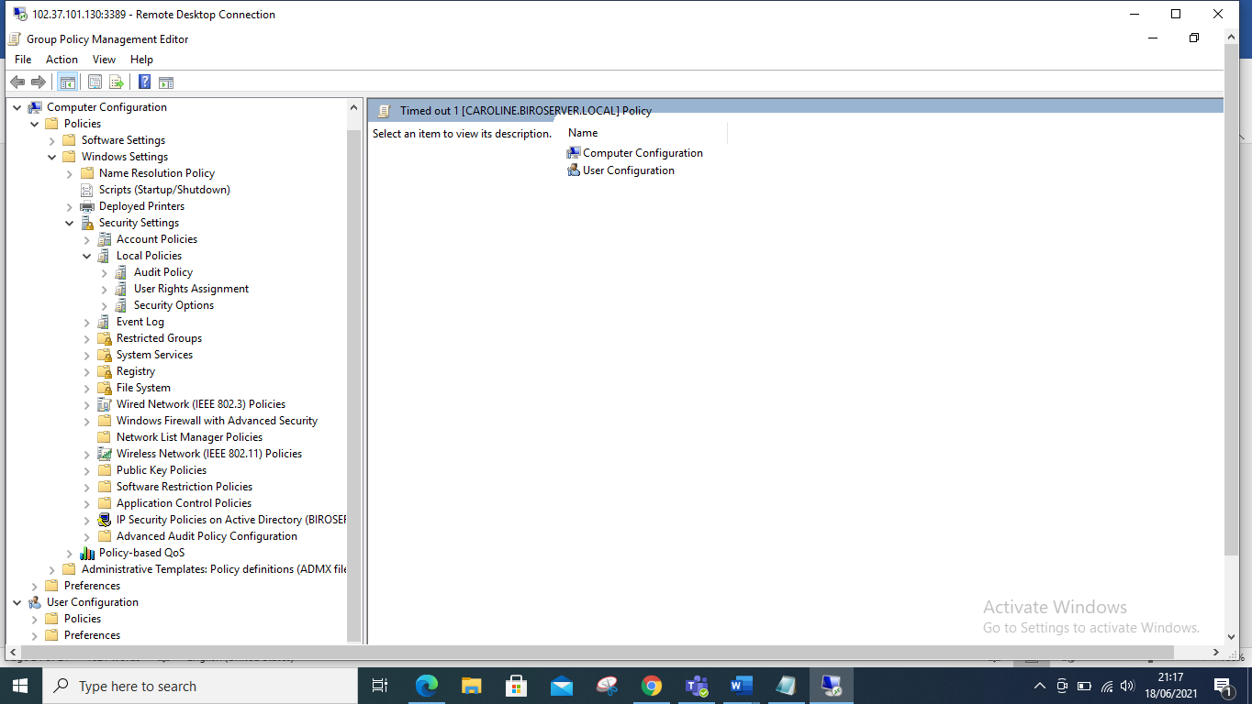

8.Once you choose security options click on Interactive logon machine inactivity limit.

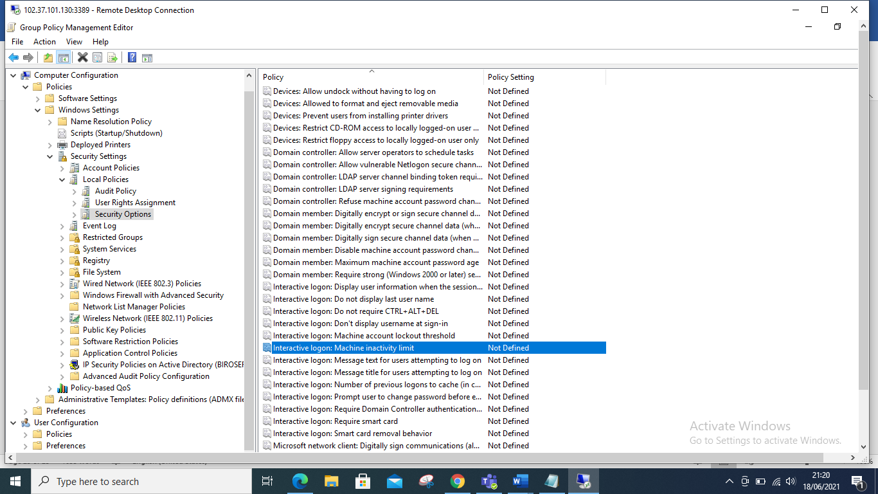

9. A pop up box appears, tick on define the policy, then input the seconds that you would want for the time out., I input 300 seconds and that’s means the session will time out after 5 minutes. Then click apply and finally okay.

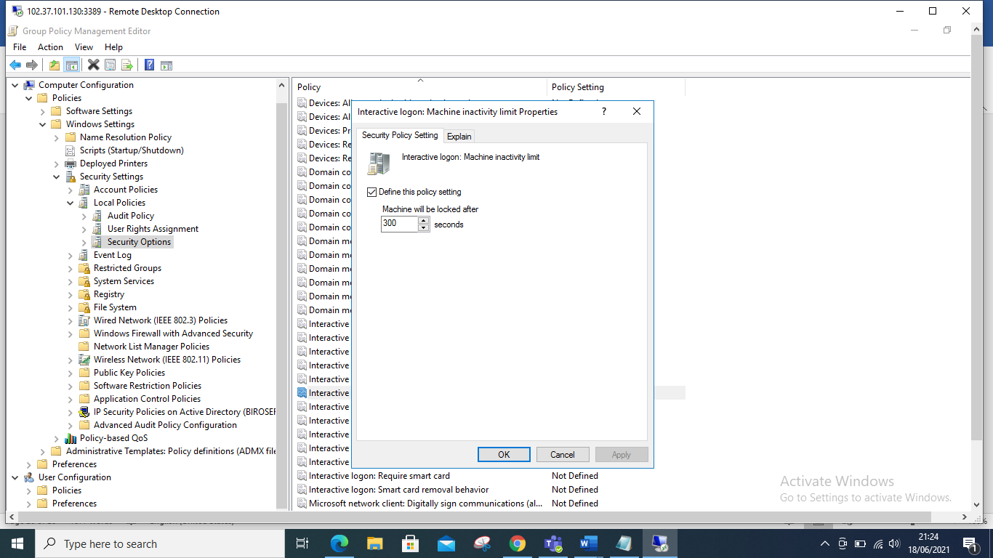

10.We go back to our security Management and click on scope , then under security filtering we can see authenticated users, we can then add the Accounting Department. Known as Accounts operators.

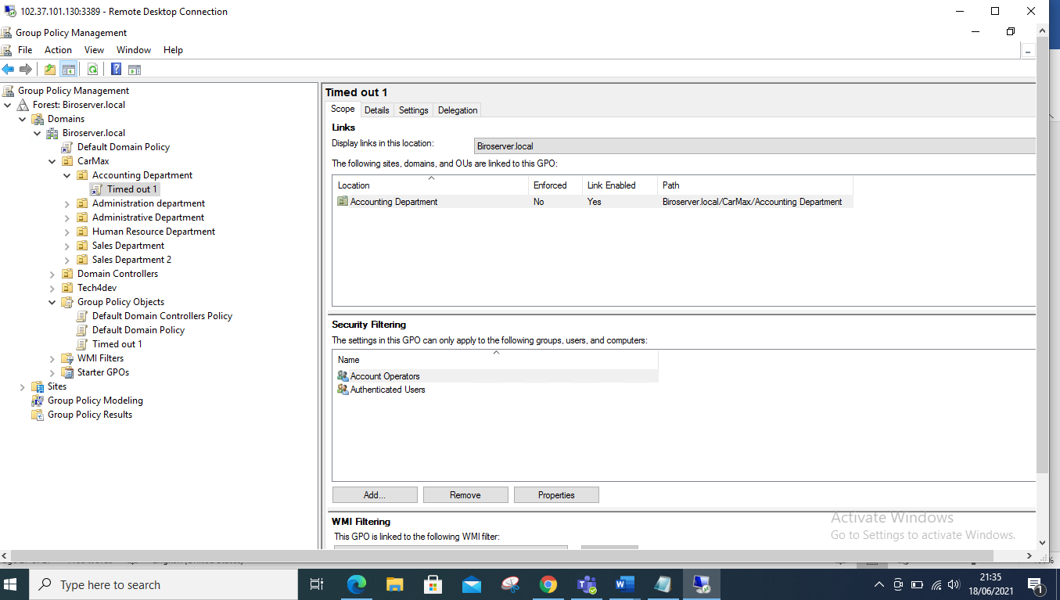

11. Hence to avoid conflict of interest we can we can remove the authenticated users., Click on authenticated Users and click Remove.

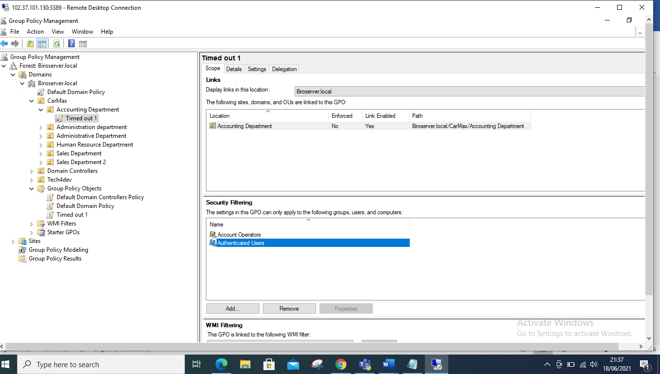

12. Hence we have removed the authenticated Users.

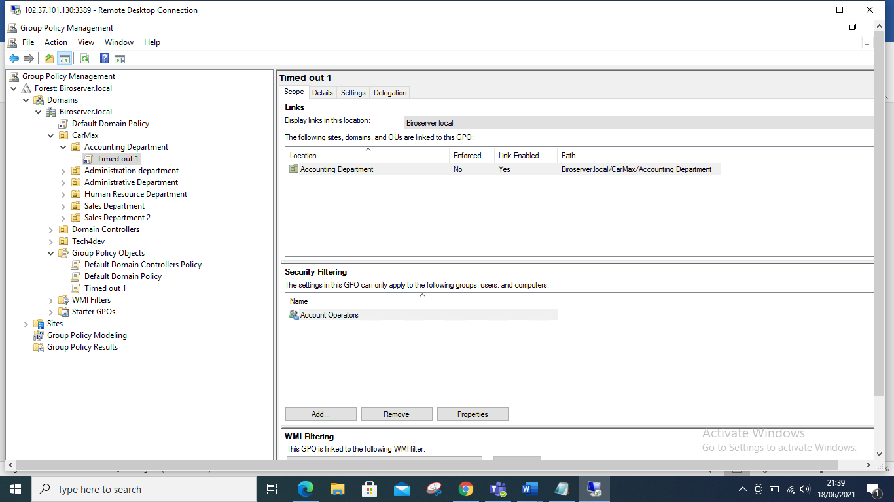

END